ADTA-DAST 5900/5750.501: Applied Natural Language Processing
Project: Results of testing and deployment of each significant dialogue flow
By:- Bhawana Rohile, Sarika Gaind, Aamir Omar

Introduction
The goal of testing was to make sure our AI agent built in GCP Dialogflow CX for handling patient appointments as planned. We focused on Testing and Implementation for the entire appointment system: scheduling, rescheduling, and canceling the appointments. Essentially, we tested each flow from the agent to ensure that it captures all the necessary details, handles errors gracefully, and smooth transitions between the different flows. This guarantees a reliable and straightforward experience for every patient needing to manage their appointment.
Test cases
Below test cases were executed as part of Testing in draft environment
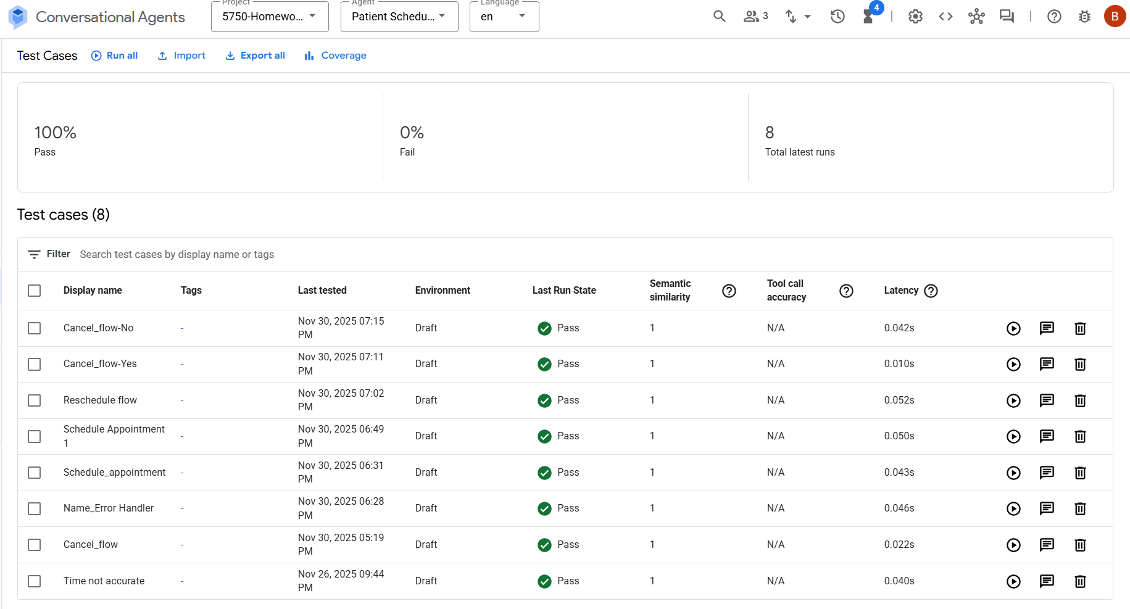
- Schedule Appointment
We tested the Schedule Appointment flow to ensure that the agent captures the required details for scheduling the appointment and shares the confirmation number after all the required details are filled.
Step | User Action (Utterance) | Expected Agent Response/Action | Pass/Fail Criteria
- Initiate conversation | Hello | “Welcome to GreenCare Clinic. What would you like to do?  Schedule, Reschedule, Cancel | Pass
- Ask for the intended action (Schedule, Reschedule, Cancel appointment) | Schedule | Agent initiates the schedule appointment flow. | Pass
- Collect personal details | Patient Name, DOB, Contact no, Insurance provider | Agent asks for  Full name  DOB  Contact no  Insurance Provider | Pass
- Collect Appointment preferences | Appointment type  Appointment reason  Provider name  Clinic location | Agent asks for  Appointment type  Appointment reason  Provider name  Clinic location | Pass
- Confirm details |  | Agent shares the summary of details entered by patient and asks for confirmation | Pass
- Appointment confirmation | Yes | Agent shares the Confirmation number | Pass
- End session |  | Agent ends the session | Pass

Screenshots
Step 1
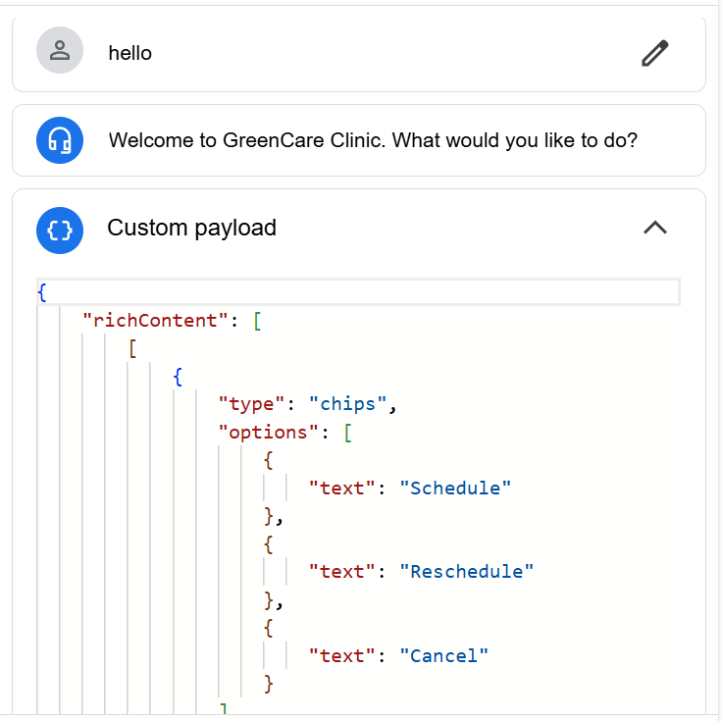
Step 2
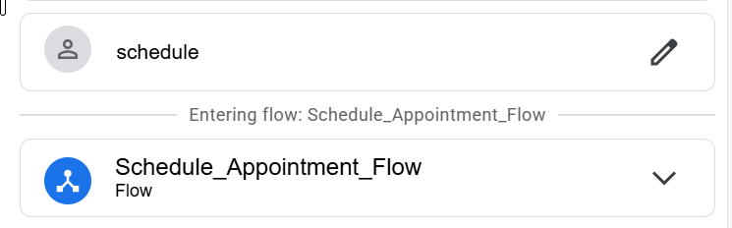
Step 3
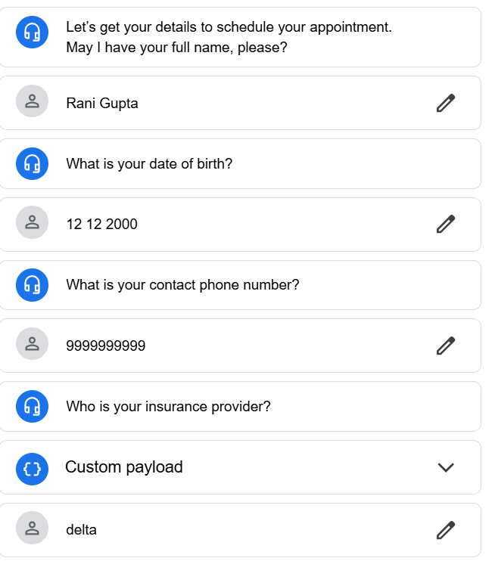
Step 4
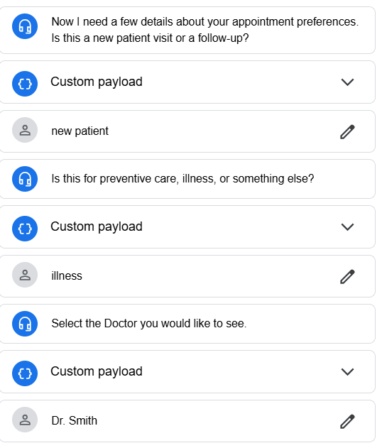
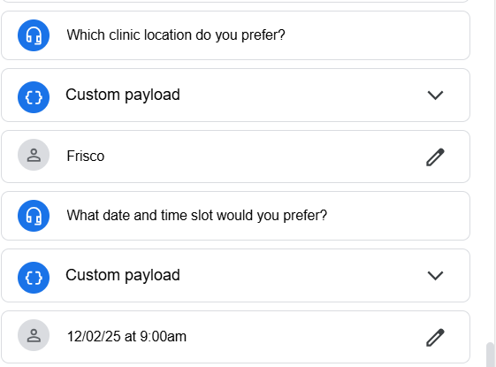
Step 5,6,7
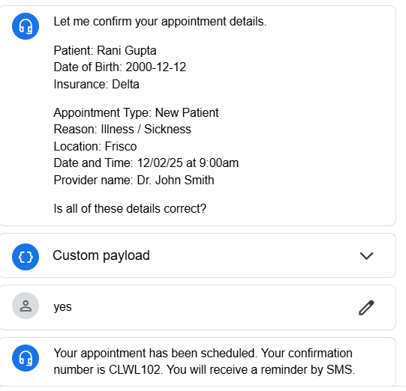

- Reschedule Appointment
Step | User Action (Utterance) | Expected Agent Response/Action | Pass/Fail Criteria
- Initiate conversation | Hello | “Welcome to GreenCare Clinic. What would you like to do?  Schedule, Reschedule, Cancel | Pass
- Ask for the intended action (Schedule, Reschedule, Cancel appointment) | Reschedule | Agent initiates the Reschedule appointment flow. | Pass
- Ask for the appointment confirmation number | Confirmation number | Agent confirms the confirmation number and initiate Schedule appointment flow | Pass
- Collect personal details | Patient Name, DOB, Contact no, Insurance provider | Agent asks for  Full name  DOB  Contact no  Insurance Provider | Pass
- Collect Appointment preferences | Appointment type  Appointment reason  Provider name  Clinic location | Agent asks for  Appointment type  Appointment reason  Provider name  Clinic location | Pass
- Confirm details |  | Agent shares the summary of details entered by patient and asks for confirmation | Pass
- Appointment confirmation | Yes | Agent shares the Confirmation number | Pass
- End session |  |  | Pass

Screenshots
Step 1,2,3
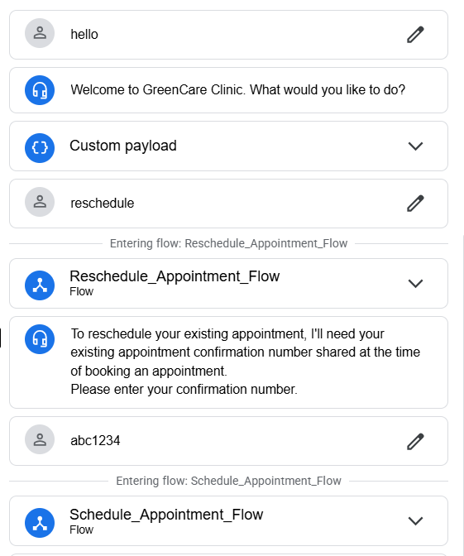
Step 4
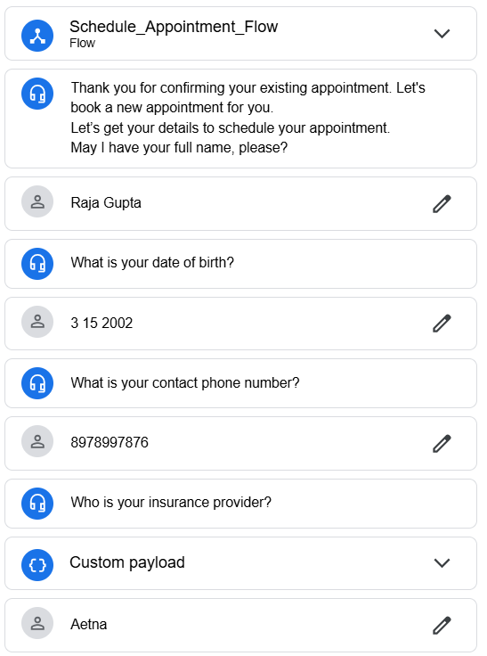
Step 5
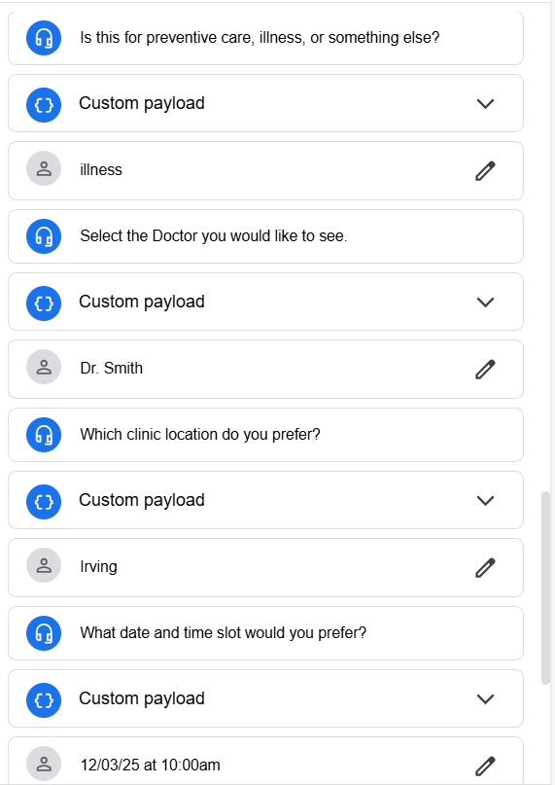
Step 6,7,8
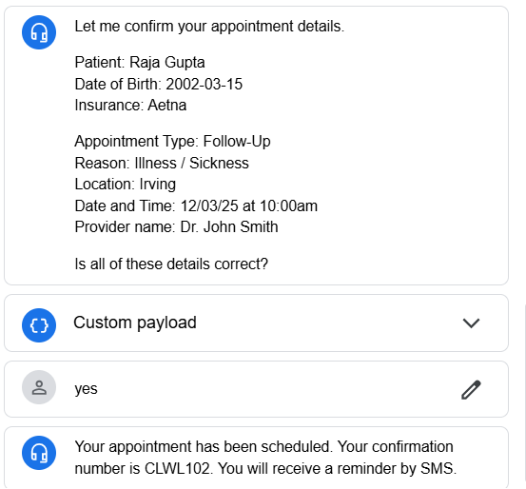
- Cancel Appointment
Step | User Action (Utterance) | Expected Agent Response/Action | Pass/Fail Criteria
- Initiate conversation | Hello | “Welcome to GreenCare Clinic. What would you like to do?  Schedule, Reschedule, Cancel | Pass
- Ask for the intended action (Schedule, Reschedule, Cancel appointment) | Reschedule | Agent initiates the Reschedule appointment flow. | Pass
- Ask for the appointment confirmation number | Confirmation number | Agent confirms the confirmation number and initiate Cancel appointment flow | Pass
- Confirms the cancellation and cancels the appointment on ‘Yes’ | Yes | Agen confirms the cancellation by asking patient if he is sure to cancel the appointment and cancel on ‘Yes/yes’ input | Pass
- Confirms the cancellation and keeps the appointment on ‘No’ | No | Agen confirms the cancellation by asking patient if he is sure to cancel the appointment and keeps the appointment on ‘No/no’ input | Pass
- End session |  |  | Pass

Screenshots
Step 1,2,3,4
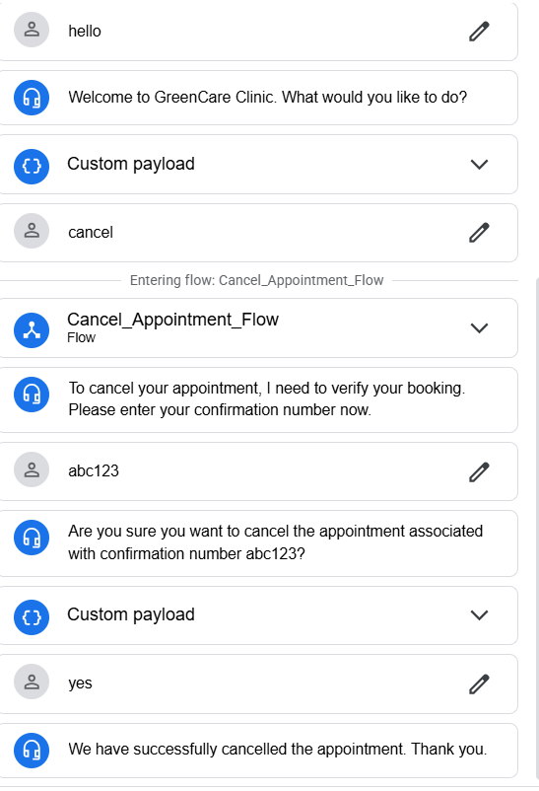
Step 1,2,3,5
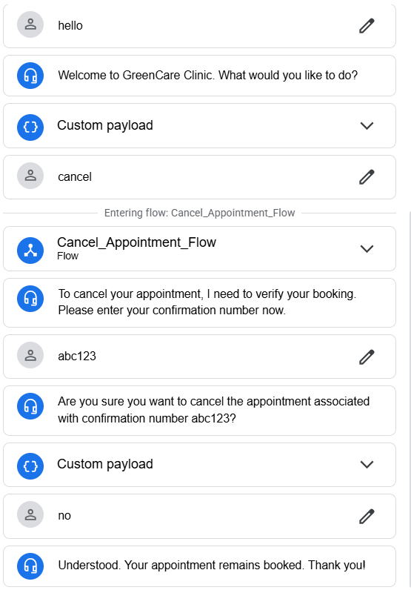
- State Handers
Step | User Action (Utterance) | Expected Agent Response/Action | Pass/Fail Criteria
- Initiate conversation | Hello | “Welcome to GreenCare Clinic. What would you like to do?  Schedule, Reschedule, Cancel | Pass
- Ask for the intended action (Schedule, Reschedule, Cancel appointment) | Schedule | Let me get a few details about you. | Pass
- Initiate flow as per the action |  |  | Pass
- Collect personal details |  | Please enter your full name. | Pass
- Collect personal details | S G | I did not get it. Please enter your full name | Fail
- Collect personal details and continue with the flow | Sara Gaind | Let me get your appointment preferences | Pass
- Appointment Preferences | Date and Time | Confirmation Message | Pass
- End Session | Yes | Your appointment has been scheduled. Your confirmation number is CLWL102. You will receive a reminder by SMS. | Pass

Step 1-2
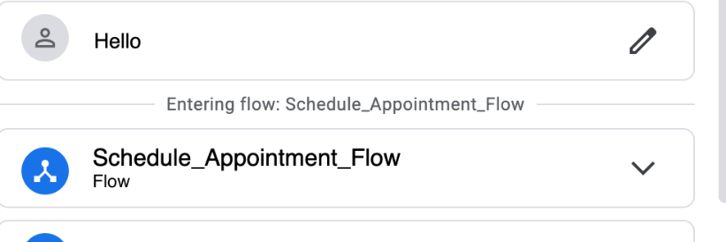
Step 3-6
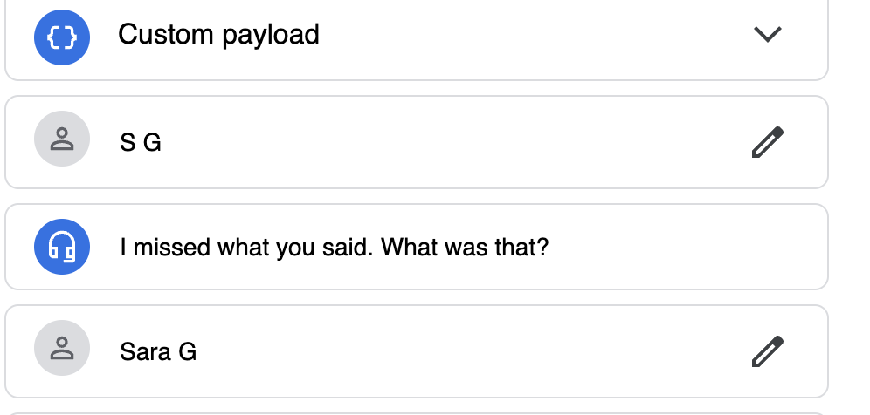
Step 7-8
